Mock Pura Belpré Awards – CSD, Oregon
Hillsboro Public Library-Main
December 12, 2015

Best author: Margarita Engle for “Enchanted Air. Two Cultures, Two Wings. A Memoir”. Published by Atheneum Books for Young Children (New York).
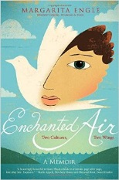

Best illustrator: Duncan Tonatiuh for “Funy Bones. Posada and His Day of the Dead Calaveras”. Published by Abrams Books for Young Readers (New York).
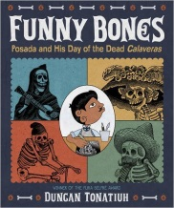

Honor Awards:

Author: Jorge Argueta for “Salsa. Un poema para cocinar / A Cooking Poem”. Published by Groundwood Books / House of Anansi Press (Toronto; Berkeley).
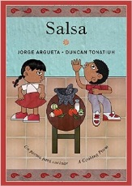
Meg Medina for “Mango, Abuela, and Me” / “Mango, Abuela y yo”. Published by Candlewick Press (Somerville, Massachusetts).
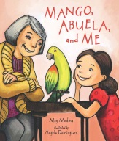
Margarita Engle for “Drum Dream Girl. How One Girl’s Courage Changed Music”. Published by Houghton Mifflin Harcourt (Boston).
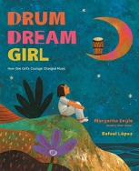

Illustrator: Rafael López for “Drum Dream Girl. How One Girl’s Courage Changed Music”. Published by Houghton Mifflin Harcourt (Boston).
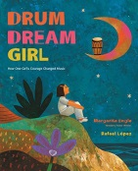
Angela Dominguez for “Mango, Abuela, and Me” / “Mango, Abuela y yo”. Published by Candlewick Press (Somerville, Massachusetts).
